**Task No. 1:** Create an array of length 10 of integers. Values ranging from 1 to 50.

1. Find all pair of elements whose sum is 25.

**Solution:**

int[] a = new int[10];

Console.WriteLine("Enter Values Whose range is in between 1 to 50");

for (int i = 0; i < 10; i++)

{

Console.Write("Enter Value In Index {0} : ",(i+1));

a[i] = int.Parse(Console.ReadLine());

if (a[i] < 0 || a[i] > 50)

{

Console.WriteLine("Number is out of range");

break;

}

}

int count = 0;

for (int j = 0; j < a.Length; j++)

{

for (int k = (j+1); k < a.Length; k++)

{

if (a[j]+a[k]==25)

{

Console.WriteLine("At index[{0} & {1}] the values {2} {3} have sum = 25", j, k, a[j], a[k]);

++count;

}

}

}

if (count==0)

{

Console.WriteLine("There Is No Element Having The Sum Of 25");

}

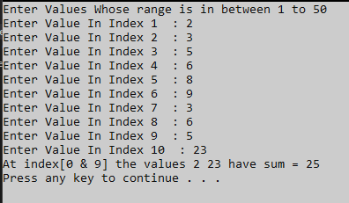**Output:**

2. Find the number of elements of A which are even, and the number of elements of A which are odd.

**Solution:**

int[] a = new int[10];

int x = 0;

int b = 0;

Console.WriteLine("Enter Values Whose range is in between 1 to 50");

for (int i = 0; i < 10; i++)

{

Console.Write("Enter Number At Index {0} : ",(i+1));

a[i] = int.Parse(Console.ReadLine());

if (a[i] < 0 || a[i] > 50)

{

Console.WriteLine("Value is out of range");

break;

}

if (a[i] % 2 == 0)

{

Console.WriteLine("The number {0} is = Even", a[i]);

x++;

}

else

{

Console.WriteLine("The number {0} is = Odd", a[i]);

b++;

}

}

Console.WriteLine("Total even numbers = [{0}] : Total Odd numbers= [{1}]", x, b);

Console.Read();

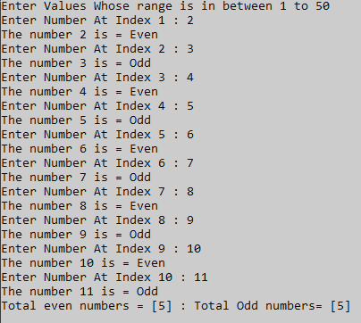**Output:**

3. Write a procedure which finds the average of the value of A.

**Solution:**

int[] a = new int[10];

double x = 0;

double avg = 0;

Console.WriteLine("enter values whose range is in between 1 to 50");

for (int i = 0; i < 10; i++)

{

Console.Write("Enter Number At Index {0} : ",(i+1));

a[i] = int.Parse(Console.ReadLine());

if (a[i] < 0 || a[i] > 50)

{

Console.WriteLine("value is out of range");

break;

}

}

for (int j = 0; j < 10; j++)

{

x += a[j];

}

Console.WriteLine("The sum of the numbers = {0}", x);

avg = x / a.Length;

Console.WriteLine("The Average of numbers is : {0}", avg);

**Output:**

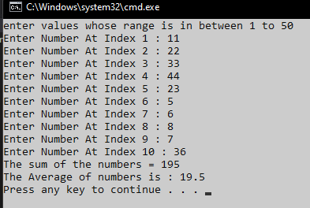

**Task No. 2:** Write a program which input 2 matrix of user defined rows and columns and perform following operation

1. Display/Print as a Matrix

**Solution:**

int i, j, n;

int[,] arr1 = new int[5, 5];

int[,] brr1 = new int[5, 5];

int[,] crr1 = new int[5, 5];

Console.Write("Input the size of the square matrix: ");

n = Convert.ToInt32(Console.ReadLine());

Console.Write("Input elements in the first matrix :\n");

for (i = 0; i < n; i++)

{

for (j = 0; j < n; j++)

{

Console.Write("element - [{0},{1}] : ", i, j);

arr1[i, j] = Convert.ToInt32(Console.ReadLine());

if (arr1[i, j] < 0 || arr1[i, j] > 50)

{

Console.WriteLine("No out of range");

}

}

}

Console.Write("Input elements in the second matrix :\n");

for (i = 0; i < n; i++)

{

for (j = 0; j < n; j++)

{

Console.Write("element - [{0},{1}] : ", i, j);

brr1[i, j] = Convert.ToInt32(Console.ReadLine());

if (brr1[i, j] < 0 || brr1[i, j] > 50)

{

Console.WriteLine("No out of range");

}

}

}

Console.Write("\nThe First matrix is :\n");

for (i = 0; i < n; i++)

{

Console.Write("\n");

for (j = 0; j < n; j++)

Console.Write("{0}\t", arr1[i, j]);

}

Console.Write("\nThe Second matrix is :\n");

for (i = 0; i < n; i++)

{

Console.Write("\n");

for (j = 0; j < n; j++)

Console.Write("{0}\t", brr1[i, j]);

}

Console.WriteLine("\n");

**Output:**

1. Addition of Matrix

**Solution:**

int i, j, n;

int[,] arr1 = new int[50, 50];

int[,] brr1 = new int[50, 50];

int[,] crr1 = new int[50, 50];

Console.Write("Input the size of the square matrix: ");

n = Convert.ToInt32(Console.ReadLine());

Console.Write("Input elements in the first matrix :\n");

for (i = 0; i < n; i++)

{

for (j = 0; j < n; j++)

{

Console.Write("element - [{0},{1}] : ", i, j);

arr1[i, j] = Convert.ToInt32(Console.ReadLine());

}

}

Console.Write("Input elements in the second matrix :\n");

for (i = 0; i < n; i++)

{

for (j = 0; j < n; j++)

{

Console.Write("element - [{0},{1}] : ", i, j);

brr1[i, j] = Convert.ToInt32(Console.ReadLine());

}

}

Console.Write("\nThe First matrix is :\n");

for (i = 0; i < n; i++)

{

Console.Write("\n");

for (j = 0; j < n; j++)

Console.Write

("{0}\t", arr1[i, j]);

}

Console.Write("\nThe Second matrix

is :\n");

for (i = 0; i < n; i++)

{

Console.Write("\n");

for (j = 0; j < n; j++)

Console.Write

("{0}\t", brr1[i, j]);

}

/* calculate the sum of the matrix */

for (i = 0; i < n; i++)

for (j = 0; j < n; j++)

crr1[i, j]

= arr1[i, j] + brr1[i, j];

Console.Write("\nThe Addition of

two matrix is : \n");

for (i = 0; i < n; i++)

{

Console.Write("\n");

for (j = 0; j < n; j++)

Console.Write

("{0}\t", crr1[i, j]);

}

Console.Write("\n\n");

**Output:**

1. Subtraction of Matrix

**Solution:**

int i, j, n;

int[,] arr1 = new int[50, 50];

int[,] brr1 = new int[50, 50];

int[,] crr1 = new int[50, 50];

Console.Write("Input the size of the square matrix: ");

n = Convert.ToInt32(Console.ReadLine());

Console.Write("Input elements in the first matrix :\n");

for (i = 0; i < n; i++)

{

for (j = 0; j < n; j++)

{

Console.Write("element - [{0},{1}] : ", i, j);

arr1[i, j] = Convert.ToInt32(Console.ReadLine());

}

}

Console.Write("Input elements in the second matrix :\n");

for (i = 0; i < n; i++)

{

for (j = 0; j < n; j++)

{

Console.Write("element - [{0},{1}] : ", i, j);

brr1[i, j] = Convert.ToInt32(Console.ReadLine());

}

}

Console.Write("\nThe First matrix is :\n");

for (i = 0; i < n; i++)

{

Console.Write("\n");

for (j = 0; j < n; j++)

Console.Write("{0}\t", arr1[i, j]);

}

Console.Write("\nThe Second matrix is :\n");

for (i = 0; i < n; i++)

{

Console.Write("\n");

for (j = 0; j < n; j++)

Console.Write("{0}\t", brr1[i, j]);

}

/* calculate the sum of the matrix */

for (i = 0; i < n; i++)

for (j = 0; j < n; j++)

crr1[i, j] = arr1[i, j] - brr1[i, j];

Console.Write("\nThe Subtraction of two matrix is : \n");

for (i = 0; i < n; i++)

{

Console.Write("\n");

for (j = 0; j < n; j++)

Console.Write("{0}\t", crr1[i, j]);

}

Console.Write("\n\n");

**Output:**

1. matrix multiplication

**Solution:**

int i, j, k, r1, c1, r2, c2, sum = 0;

int[,] arr1 = new int[50, 50];

int[,] brr1 = new int[50, 50];

int[,] crr1 = new int[50, 50];

Console.Write("\n\nMultiplication of two Matrices\n");

Console.Write("----------------------------------\n");

Console.Write("\nInput the number of rows and columns of the first matrix :\n");

Console.Write("Rows : ");

r1 = Convert.ToInt32(Console.ReadLine());

Console.Write("Columns : ");

c1 = Convert.ToInt32(Console.ReadLine());

Console.Write("\nInput the number of rows of the second matrix :\n");

Console.Write("Rows : ");

r2 = Convert.ToInt32(Console.ReadLine());

Console.Write("Columns : ");

c2 = Convert.ToInt32(Console.ReadLine());

if (c1 != r2)

{

Console.Write("Mutiplication of Matrix is not possible.");

Console.Write("\nColumn of first matrix and row of second matrix must be same.");

}

else

{

Console.Write("Input elements in the first matrix :\n");

for (i = 0; i < r1; i++)

{

for (j = 0; j < c1; j++)

{

Console.Write("element - [{0}],[{1}] : ", i, j);

arr1[i, j] = Convert.ToInt32(Console.ReadLine());

}

}

Console.Write("Input elements in the second matrix :\n");

for (i = 0; i < r2; i++)

{

for (j = 0; j < c2; j++)

{

Console.Write("element - [{0}],[{1}] : ", i, j);

brr1[i, j] = Convert.ToInt32(Console.ReadLine());

}

}

Console.Write("\nThe First matrix is :\n");

for (i = 0; i < r1; i++)

{

Console.Write("\n");

for (j = 0; j < c1; j++)

Console.Write("{0}\t", arr1[i, j]);

}

Console.Write("\nThe Second matrix is :\n");

for (i = 0; i < r2; i++)

{

Console.Write("\n");

for (j = 0; j < c2; j++)

Console.Write("{0}\t", brr1[i, j]);

}

//multiplication of matrix

for (i = 0; i < r1; i++)

for (j = 0; j < c2; j++)

crr1[i, j] = 0;

for (i = 0; i < r1; i++) //row of first matrix

{

for (j = 0; j < c2; j++) //column of second matrix

{

sum = 0;

for (k = 0; k < c1; k++)

sum = sum + arr1[i, k] * brr1[k, j];

crr1[i, j] = sum;

}

}

Console.Write("\nThe multiplication of two matrix is : \n");

for (i = 0; i < r1; i++)

{

Console.Write("\n");

for (j = 0; j < c2; j++)

{

Console.Write("{0}\t", crr1[i, j]);

}

}

}

Console.Write("\n\n");

**Output:**

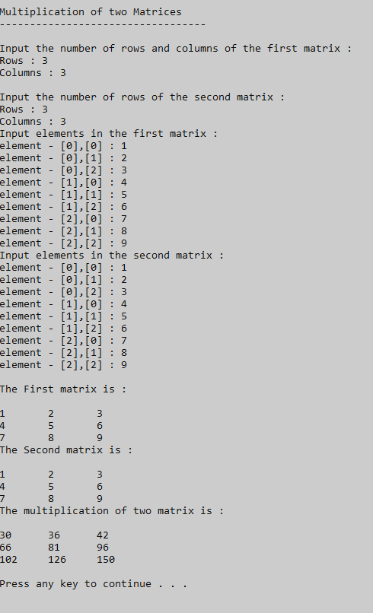

1. Determinant

**Solution:**

int[,] matrix = new int[2, 2];

for (int i = 0; i < 2; i++)

{

for (int j = 0; j < 2; j++)

{

Console.WriteLine("Enter the Value for index [{0},{1}]", i, j);

matrix[i, j] = Convert.ToInt32(Console.ReadLine());

}

}

int c = 0;

Console.WriteLine("--------------------------------");

Console.WriteLine("Taking Determenant");

Console.WriteLine("--------------------------------");

Console.WriteLine("\n");

for (int i = 0; i < 1; i++)

{

for (int j = 0; j < 1; j++)

{

c = matrix[i, j];

}

}

int d = 0;

for (int i = 1; i < 2; i++)

{

for (int j = 1; j < 2; j++)

{

d = matrix[i, j];

}

}

int diagnol1 = d * c;

Console.WriteLine("Diagnol 1 :" + diagnol1);

int e = 0;

for (int i = 0; i < 1; i++)

{

for (int j = 1; j < 2; j++)

{

e = matrix[i, j];

}

}

int f = 0;

for (int i = 1; i < 2; i++)

{

for (int j = 0; j < 1; j++)

{

f = matrix[i, j];

}

}

int diagonal2 = f * e;

Console.WriteLine("Diagnol 2 :" + diagonal2);

Console.WriteLine("--------------------------------");

int determinant = diagnol1 - diagonal2;

Console.WriteLine("Subtact: [Diagnol 1- Diagnol 2] ");

Console.WriteLine("\t = {0} - {1} = {2}", diagnol1, diagonal2, diagnol1 - diagonal2);

Console.WriteLine("--------------------------------");

Console.WriteLine("Determinant: {0}", determinant);

**Output:**

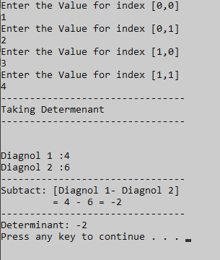

f. Inverse

**Solution:**

Console.WriteLine("=====INVERSE OF MATRIX======");

double[,] matric1 = new double[2, 2];

for (int i = 0; i < matric1.GetLength(0); i++)

{

for (int j = 0; j < matric1.GetLength(1); j++)

{

Console.Write("enter the values of matrix {0},{1} : ", i, j);

matric1[i, j] = Convert.ToDouble(Console.ReadLine());

}

}

Console.WriteLine("\n");

for (int i = 0; i < matric1.GetLength(0); i++)

{

for (int j = 0; j < matric1.GetLength(1); j++)

{

Console.Write(" " + matric1[i, j] + " ");

}

Console.WriteLine();

}

Console.WriteLine("=========INVERSE OF MATRIC======");

Console.WriteLine("\n");

double temp;

double[,] matric3 = new double[2, 2];

double ans = 0;

for (int i = 0; i < 2; i++)

{

for (int j = 0; j < 2; j++)

{

ans = matric1[0, 0] * matric1[1, 1] - matric1[0, 1] * matric1[1, 0];

}

}

for (int i = 0; i < 2; i++)

{

for (int j = 0; j < 2; j++)

{

temp = matric1[0, 0];

matric1[0, 0] = matric1[1, 1];

matric1[1, 1] = temp;

matric1[1, 0] = (-1) * (matric1[1, 0]);

Console.Write(" " + matric1[i, j] + " ");

matric1[0, 1] = (-1) * (matric1[0, 1]);

temp = matric1[0, 0];

matric1[0, 0] = matric1[1, 1];

matric1[1, 1] = temp;

}

Console.WriteLine();

}

try

{

for (int i = 0; i < 2; i++)

{

for (int j = 0; j < 2; j++)

{

if (i == 0 && j == 0)

{

matric3[0, 0] = matric1[0, 0] / ans;

// Console.WriteLine("[{0},{1}]=", i, j);

}

else if (i == 1 && j == 0)

{

matric3[1, 0] = matric1[1, 0] / ans;

// Console.WriteLine("[{0},{1}]=", i, j);

}

else if (i == 0 && j == 1)

{

matric3[0, 1] = matric1[0, 1] / ans;

// Console.WriteLine("[{0},{1}]=", i, j);

}

else if (i == 1 && j == 1)

{

matric3[1, 1] = matric1[1, 1] / ans;

// Console.WriteLine("[{0},{1}]=", i, j);

}

}

}

}

catch (Exception e)

{

Console.WriteLine(e.Message);

}

Console.WriteLine("RESULT OF DETERMINENT MATRICES");

Console.WriteLine("Determinent == {0} ", ans);

Console.WriteLine("\n");

Console.WriteLine("Inverse");

for (int i = 0; i < 2; i++)

{

for (int j = 0; j < 2; j++)

{

temp = matric3[0, 0];

matric3[0, 0] = matric3[1, 1];

matric3[1, 1] = temp;

matric3[1, 0] = (-1) * (matric3[1, 0]);

Console.Write(" " + matric3[i, j] + " ");

matric3[0, 1] = (-1) * (matric3[0, 1]);

temp = matric3[0, 0];

matric3[0, 0] = matric3[1, 1];

matric3[1, 1] = temp;

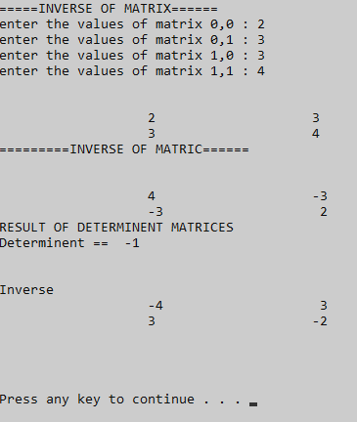 }

Console.WriteLine();

}

Console.WriteLine("\n");

Console.WriteLine("\n");

**Output:**